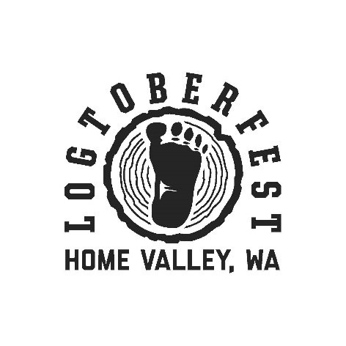

Vendors:

The Wind River Business Association, with the Skamania County Chamber of Commerce, announces Logtoberfest! This fifth annual event, celebrating the culture of Skamania County, will be held on Saturday, October 2, 2021 from 12:00 pm to 6:00 pm at Gorge-ous Weddings at Wind Mountain Ranch in Home Valley, WA.

We invite your participation in this family friendly event that includes country music, local food and craft beer, Sasquatch stories and more. To find out more about the festivities, visit: www.facebook.com/bigfootbashlogtoberfest

The Wind River Business Association will provide vendors:
- Electricity to a limited number of spaces
- Cold water nearby
- Event marketing

The vendor should bring:
- Garbage service – be prepared to dispose of your garbage
- Signs or banners, promotional materials as desired
- Serving tables, if needed
- Hot water station for sanitation if serving food
- Food Handler’s Permit and Temporary Food Service Permit
- If you need electricity, bring extension cords and mats to cover them
- Tent covering, if needed

A vendor application is enclosed. To reserve, return your agreement and a check to us as soon as possible. Vendor space is limited and will be available on a first come, first serve basis. Set up will be available at 10:00 am on Saturday, October 2 and vendor booths need to be ready by 12:00 pm. For more information, please call the Skamania Observer 912-659-2028

